# Connect QGIS to portal using oauth2 authentication

Original source based on <https://north-road.com/2022/09/16/securely-accessing-arcgis-online-agol-and-enterprise-arcgis-portal-sites-through-qgis-2022-update/>

Go to the knowledge management sharepoint and download the file located here [QGIS_oauth2_UNEP_WCMC.json](https://wcmc.sharepoint.com/:u:/s/WCMCKnowledgeManagement/EcWPeox13TBFjZiMVoClUF4B-Q5ZaJVTLm7uw7NgD6CpsQ?e=9wXZFI)

View >>>show hidden items

Save in your QGIS profile folder e.g. **C:\Users\Corinnar\AppData\Roaming\QGIS\QGIS3\profiles\default**

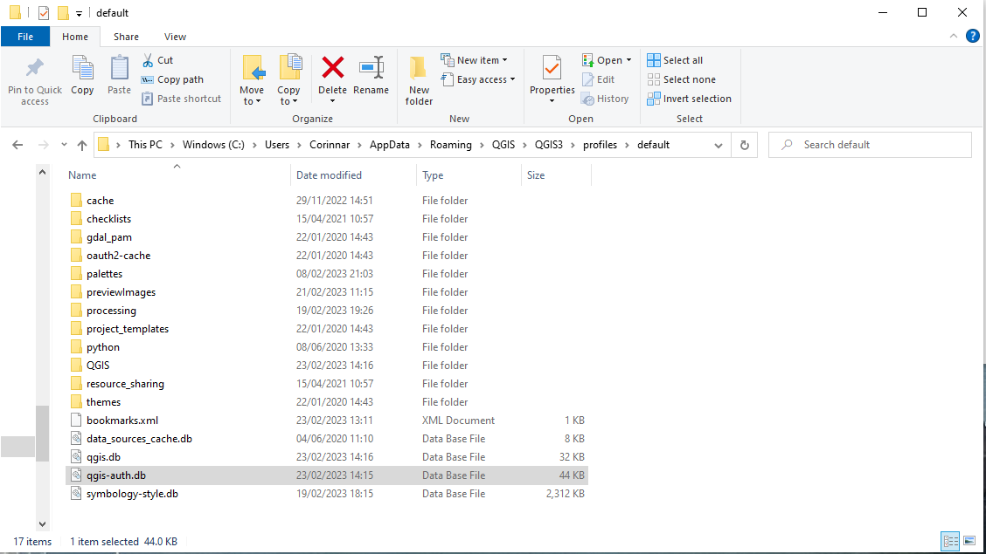

Open **QGIS**

Navigate to **Layers>>Data Source Manager**

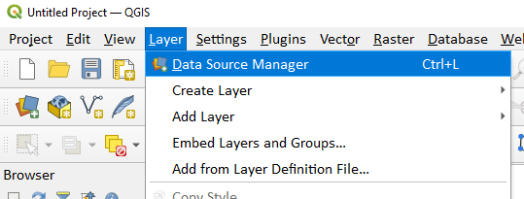

Click on **ArcGIS REST Server** in the left hand panel and then click **New**

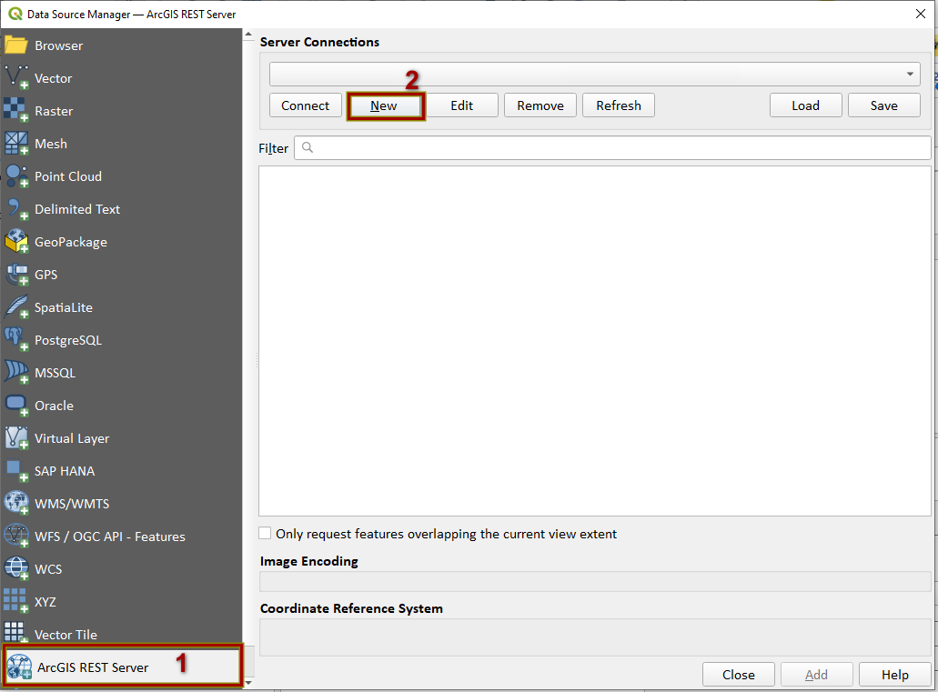

Fill out the following parameters

**Name:** UNEP-WCMC portal

**URL:** <https://data-gis.unep-wcmc.org/server/rest/services/>

**Community endpoint URL:** <https://data-gis.unep-wcmc.org/portal/sharing/rest/community/>

**Content endpoint URL:** <https://data-gis.unep-wcmc.org/portal/sharing/rest/content/>

Under Authentications click on **Configurations + button**

In the drop-down you should **UNEP-WCMC Portal (Oauth2)**

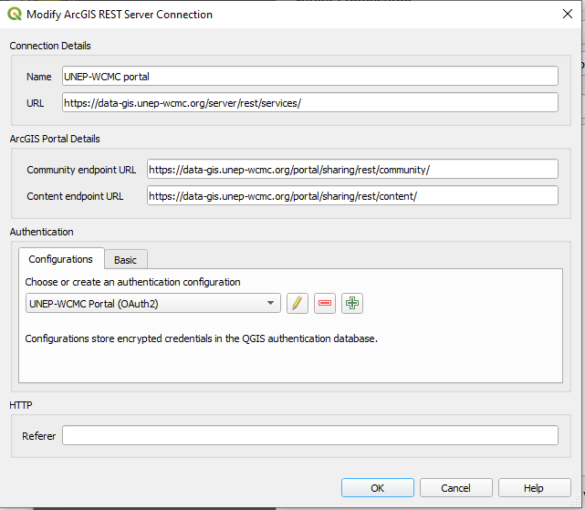

Click ok to **close**

This will take you back to the Data Source Manager Window.

Click **Connect**

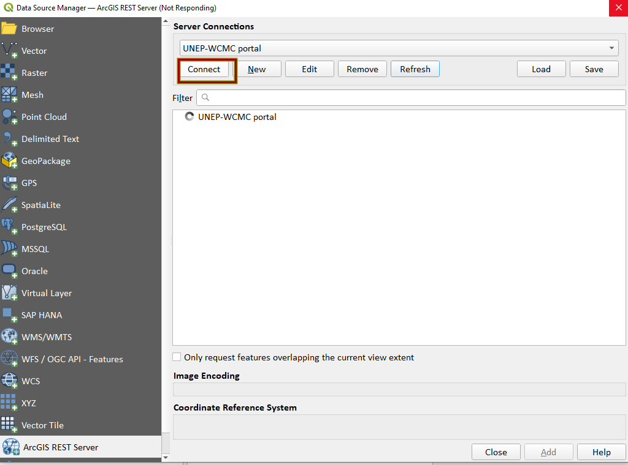

You should see two items (Groups and Services) under UNEP-WCMC portal

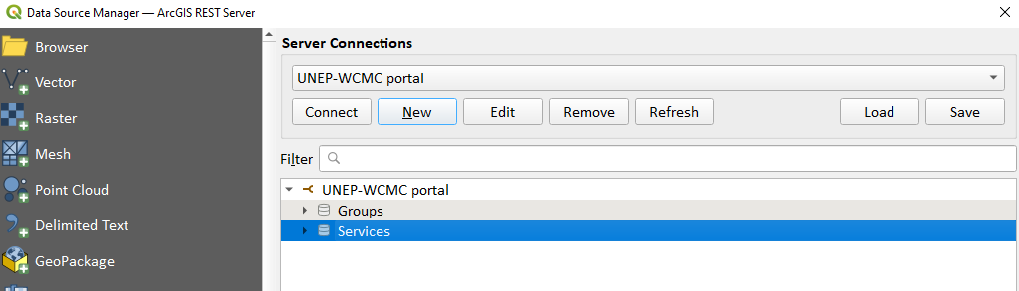

Click on the **>** arrow to expand Services

This will take you to the UNEP-WCMC portal login page

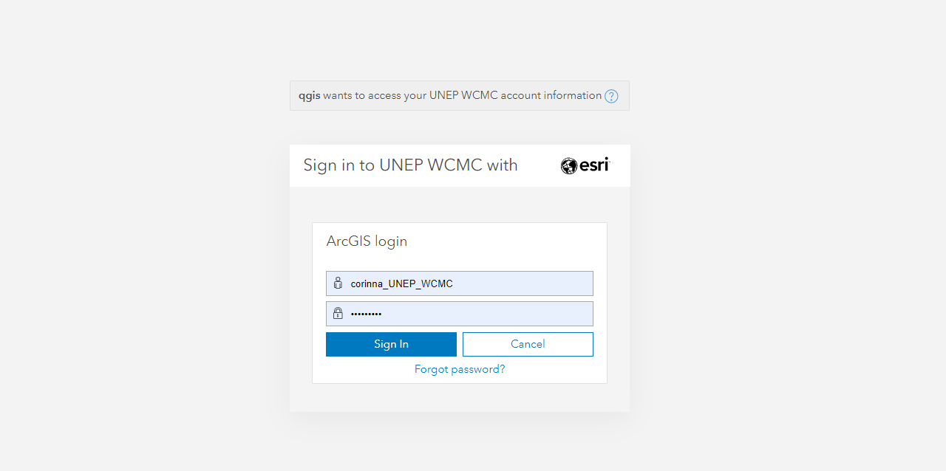

Once logged it you should get the message saying the authentication has worked and you can go back to QGIS .

you should not see this

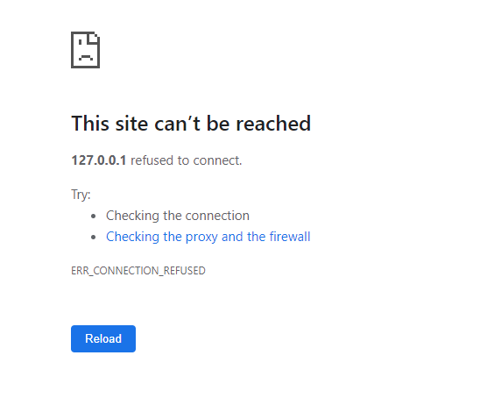

If connection has worked see all the data layers in the portal which you can add directly into your QGIS project in the same way as shapefiles, geodatabase files and geotiff raster layers.

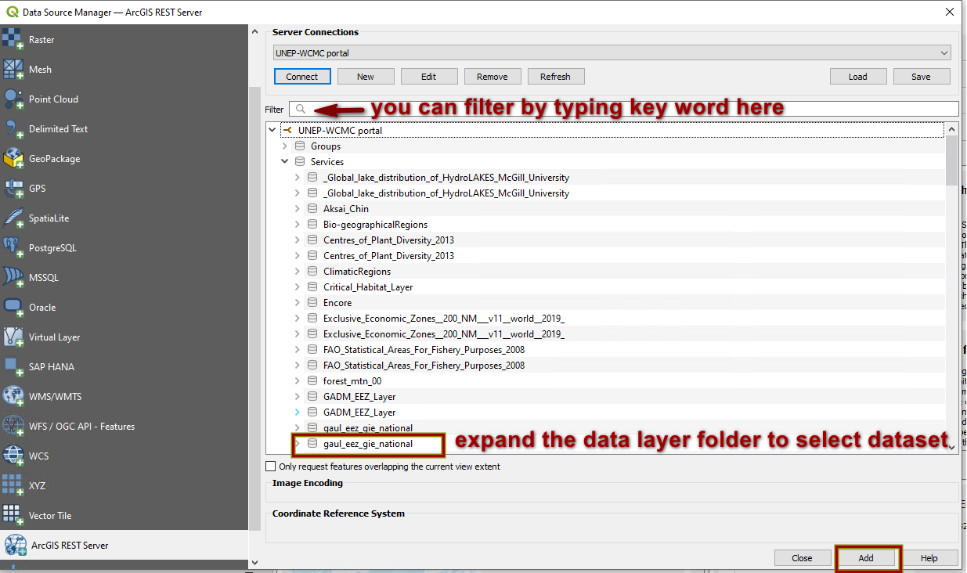

# Connect QGIS to portal using oauth2 token

(original source: based on https://toolkit.data.wa.gov.au/hc/en-gb/articles/360001044975-How-to-Add-an-ArcGIS-Server-Feature-Service-Esri-Token-Authentication-in-QGIS#connecting-to-a-service-using-token-authentication)

If the Oauth2 did not work this is an alternative method.

Let Corinna or Osgur know if you get an error still and can’t connect using Oauth2 as it is useful to know during this testing phase when and why iot is not working

Then try the below.

You can generate a token which you can specify will last from 1 hour to 2 weeks. After the specified time you will need to repeat this process to generate a new token

Navigate to this website

<https://data-gis.unep-wcmc.org/portal/sharing/rest/oauth2>

click on generate token

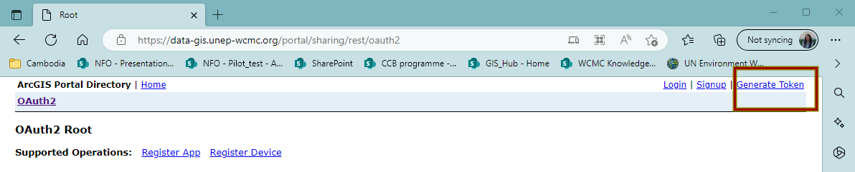

Login with your portal login

Click IP Address of this request’s origin

And click Generate Token

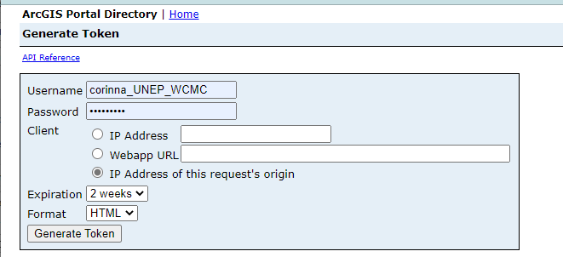

The token will appear underneath

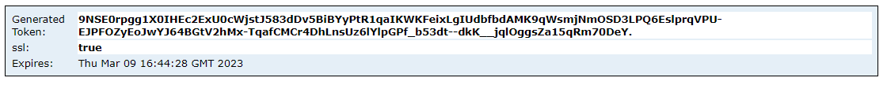

Copy the token and return to QGIS

Go back to the **Data Source Manager** and this time edit the **UNEP-WCMC Portal** connection that you already tried to set up

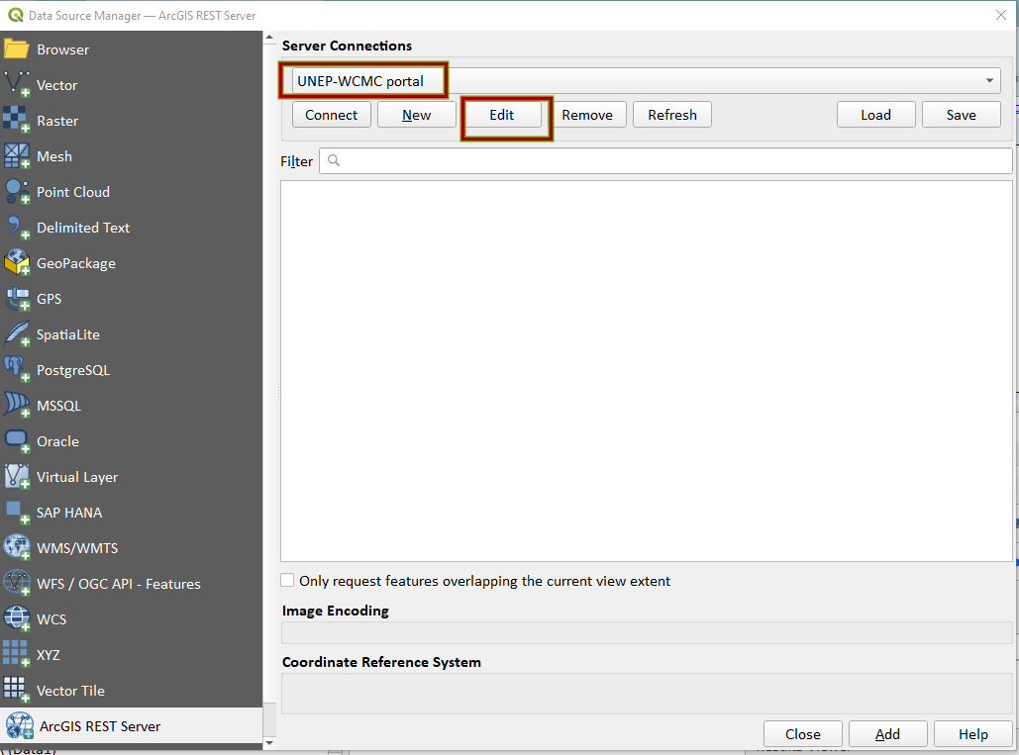

Click on the Green plus button

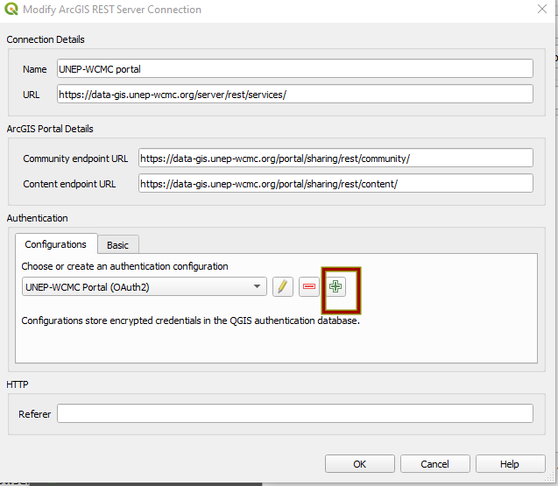

A new Authentication window opens.

Give the new authentication a name e.g. UNEP-WCMC portal token

Change the dropdown from Basic Authentication to **ESRI token**

Paste your token in the box and click **Save**

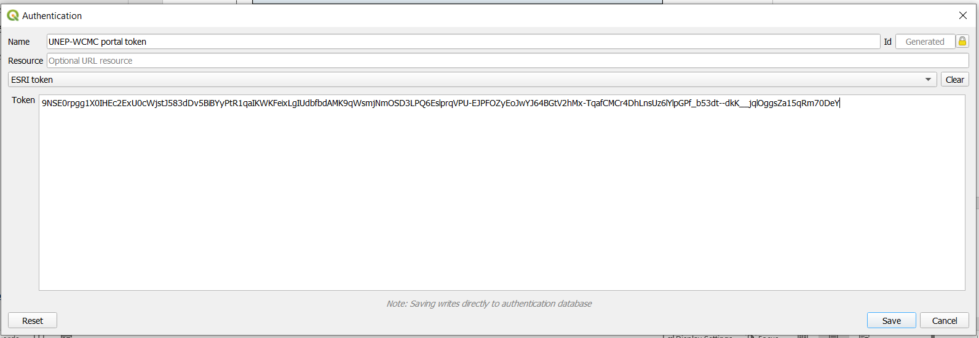

Your authentication should now be set to the ESRI Token – click ok

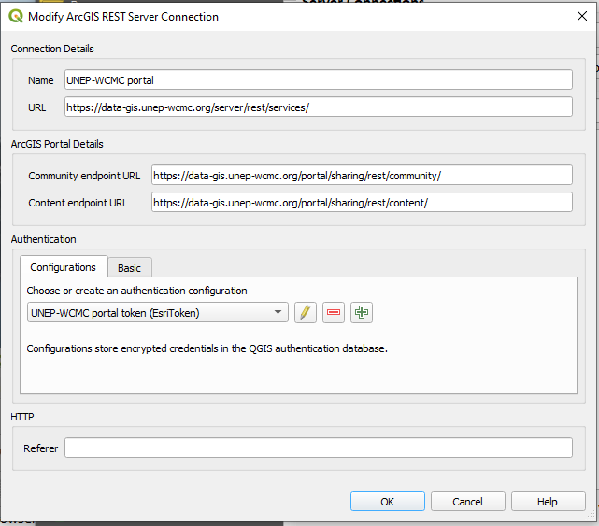

You should now be back at the Data Source Manager.

Click Connect

You should see the same as you did when you tried to connect via the Oauth2 method



You should see two items (Groups and Services) under UNEP-WCMC portal



Click on the **>** arrow to expand Services

You should see all the data layers appear!!



Let Corinna or Osgur know if you get an error still and can’t connect